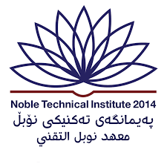

**Kurdistan Regional Government**

**Ministry of Higher Education & Scientific Research**

**Noble Institute**

**Loan Database Management**

**Prepared By**

4.Asaad Ahmad

5.Shwan Sabir

1.Hawkar Abdulla

2.Hardi Khalis

3.Omer Muzafar

**Supervised By**

Mrs.Vian Waheed Khalid

May-2024